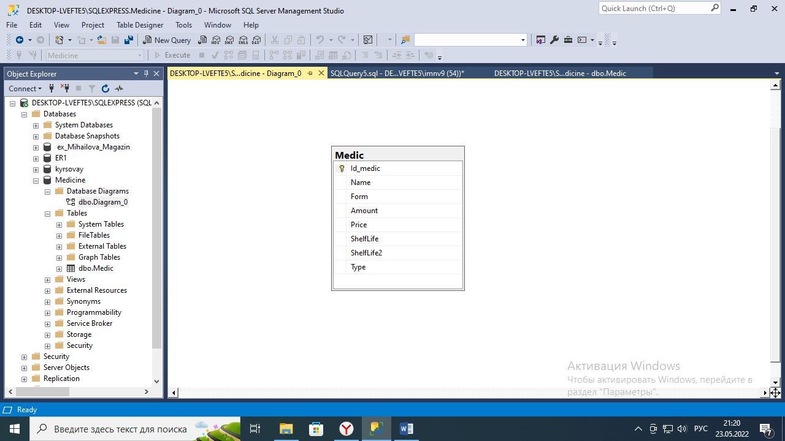

Рисунок 1. ER-диаграмма

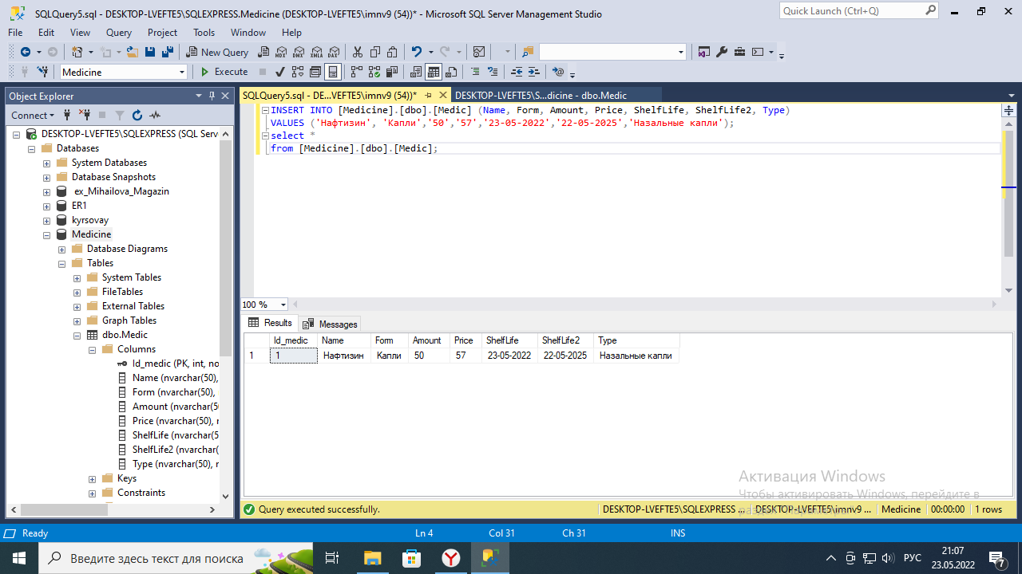

Рисунок 2. Добавление лекарства

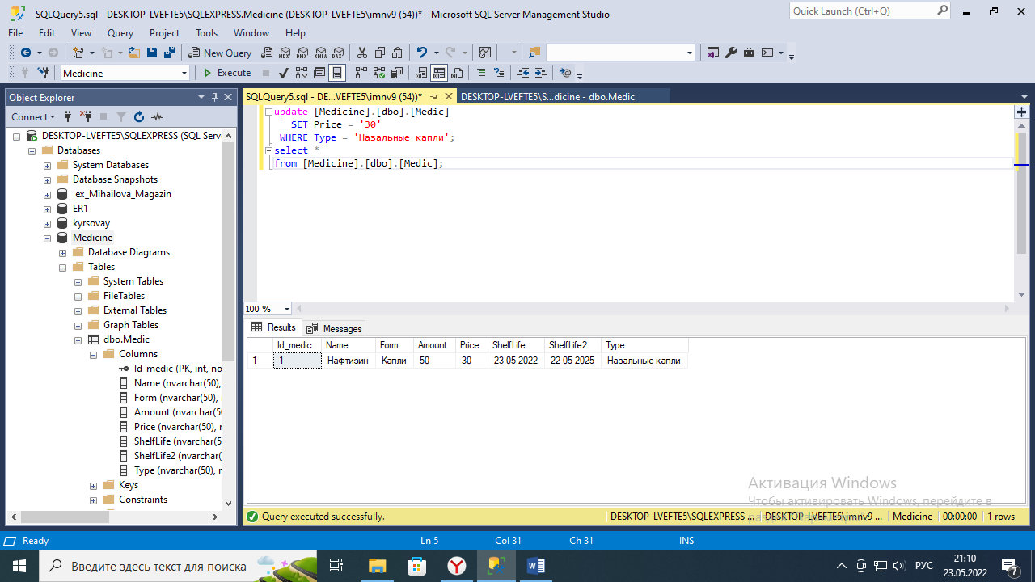

Рисунок 3. Обновление характеристики лекарства

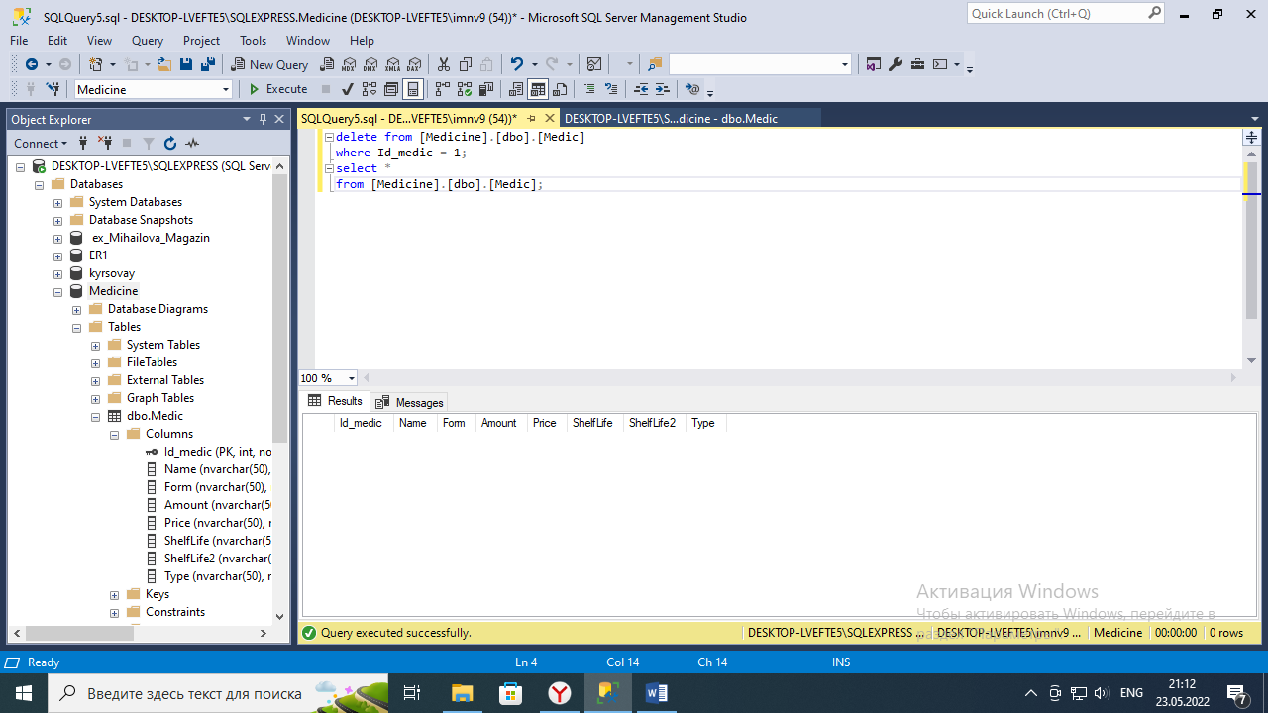

Рисунок 4. Удаление лекарства

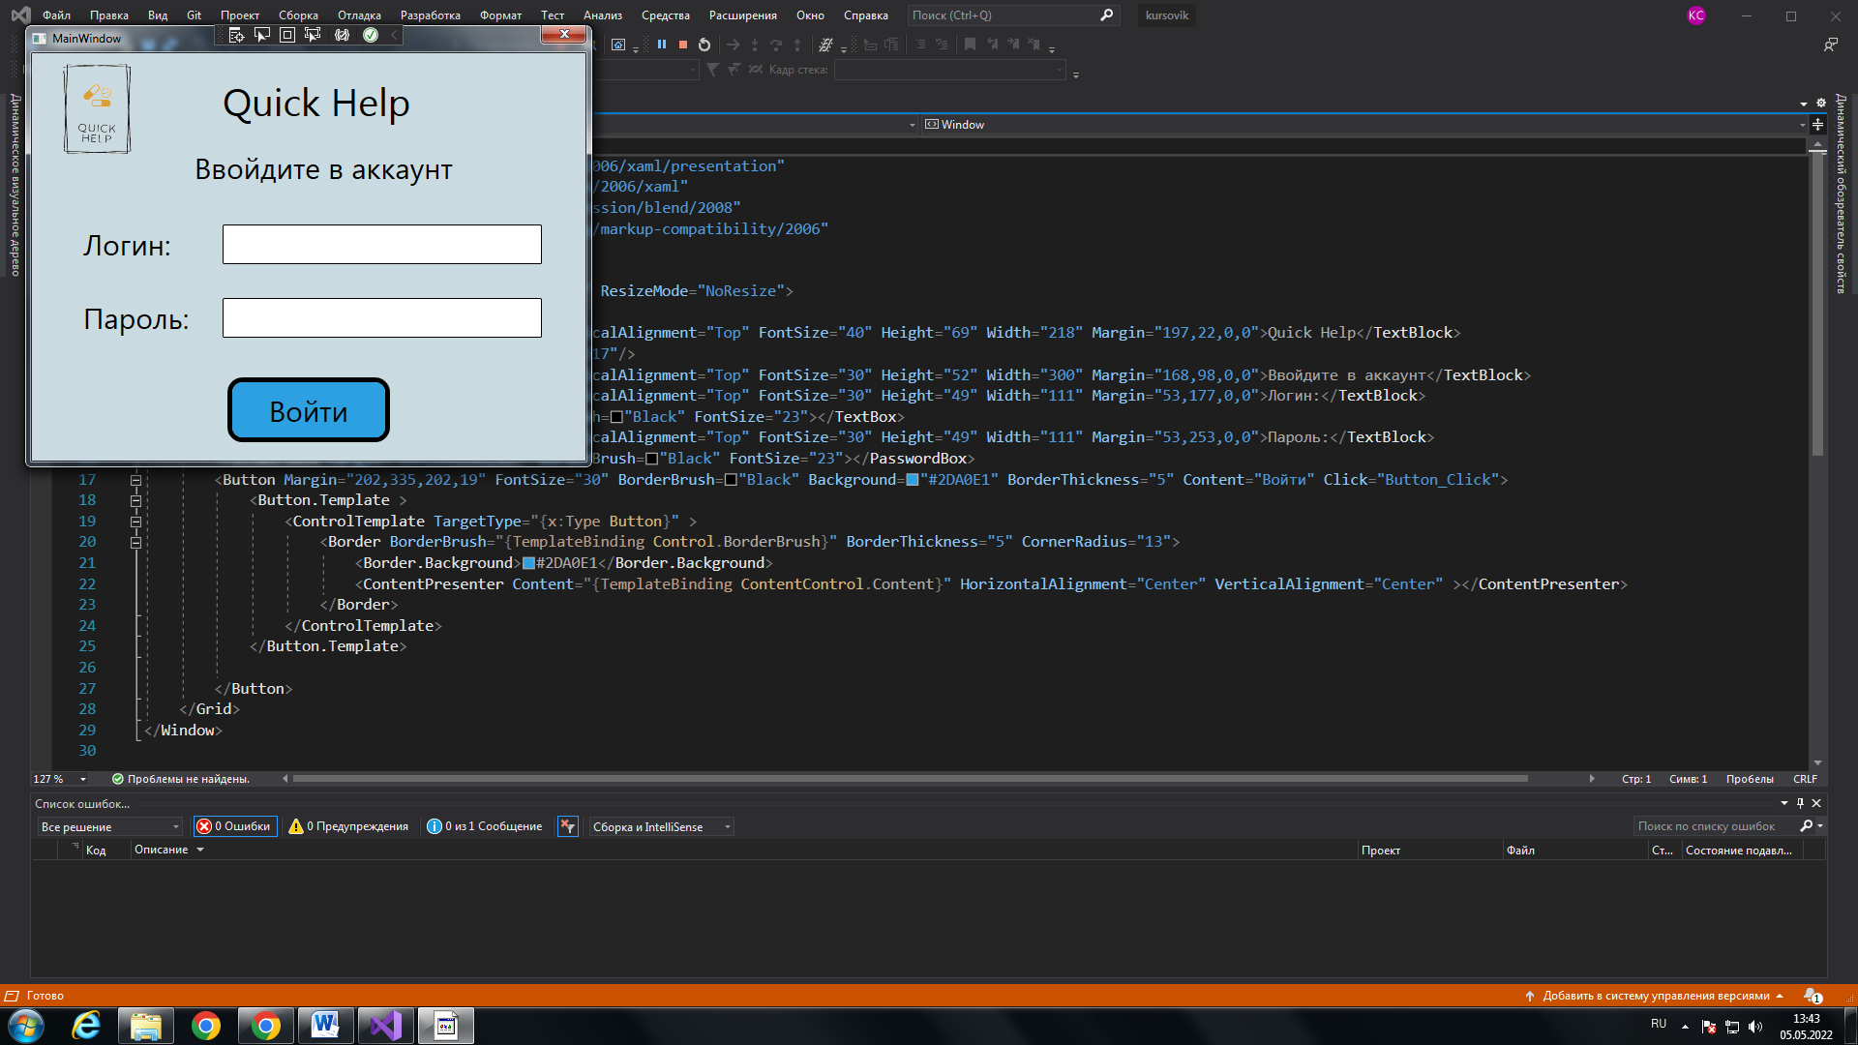

Рисунок 5. Скриншот окна входа в приложение

<Grid>

<Grid.RowDefinitions>

<RowDefinition></RowDefinition>

</Grid.RowDefinitions>

<Button Width="150" Height="70" FontSize="30" HorizontalAlignment="Right" VerticalAlignment="Top" Margin="0,50,50,0" BorderBrush="Black" Background="#2DA0E1" BorderThickness="5" Content="Выйти" Click="Button_Click">

<Button.Template >

<ControlTemplate TargetType="{x:Type Button}" >

<Border BorderBrush="{TemplateBinding Control.BorderBrush}" BorderThickness="3" CornerRadius="13">

<Border.Background>#2DA0E1</Border.Background>

<ContentPresenter Content="{TemplateBinding ContentControl.Content}" HorizontalAlignment="Center" VerticalAlignment="Center" ></ContentPresenter>

</Border>

</ControlTemplate>

</Button.Template>

</Button>

<Image Source="logo.png" Margin="30,30,0,0" Height="100" Width="100" HorizontalAlignment="Left" VerticalAlignment="Top" />

<TextBlock x:Name="FIO" Text="" FontSize="30" VerticalAlignment="Top" HorizontalAlignment="Center" Margin="0,80,0,0"></TextBlock>

<Button Margin="83,0,0,116" VerticalAlignment="Bottom" HorizontalAlignment="Left" Width="300" Height="80" FontSize="30" BorderBrush="Black" Background="#2DA0E1" BorderThickness="5" Content="Внести изменения" Click="Button_Click_1">

<Button.Template >

<ControlTemplate TargetType="{x:Type Button}" >

<Border BorderBrush="{TemplateBinding BorderBrush}" BorderThickness="3" CornerRadius="13">

<Border.Background>

<Brush>#2DA0E1</Brush>

</Border.Background>

<ContentPresenter Content="{TemplateBinding Content}" HorizontalAlignment="Center" VerticalAlignment="Center" />

</Border>

</ControlTemplate>

</Button.Template>

</Button>

<TextBlock Text="ГЛАВНАЯ СТРАНИЦА" FontSize="40" FontWeight="Black" HorizontalAlignment="Left" VerticalAlignment="Top" Margin="134,201,0,0"></TextBlock>

<Button Margin="483,0,0,116" VerticalAlignment="Bottom" HorizontalAlignment="Left" Width="150" Height="80" FontSize="30" BorderBrush="Black" Background="#2DA0E1" BorderThickness="5" Content="Склад" Click="Button_Click_2">

<Button.Template >

<ControlTemplate TargetType="{x:Type Button}" >

<Border BorderBrush="{TemplateBinding BorderBrush}" BorderThickness="3" CornerRadius="13">

<Border.Background>

<Brush>#2DA0E1</Brush>

</Border.Background>

<ContentPresenter Content="{TemplateBinding Content}" HorizontalAlignment="Center" VerticalAlignment="Center" />

</Border>

</ControlTemplate>

</Button.Template>

</Button>

</Grid>

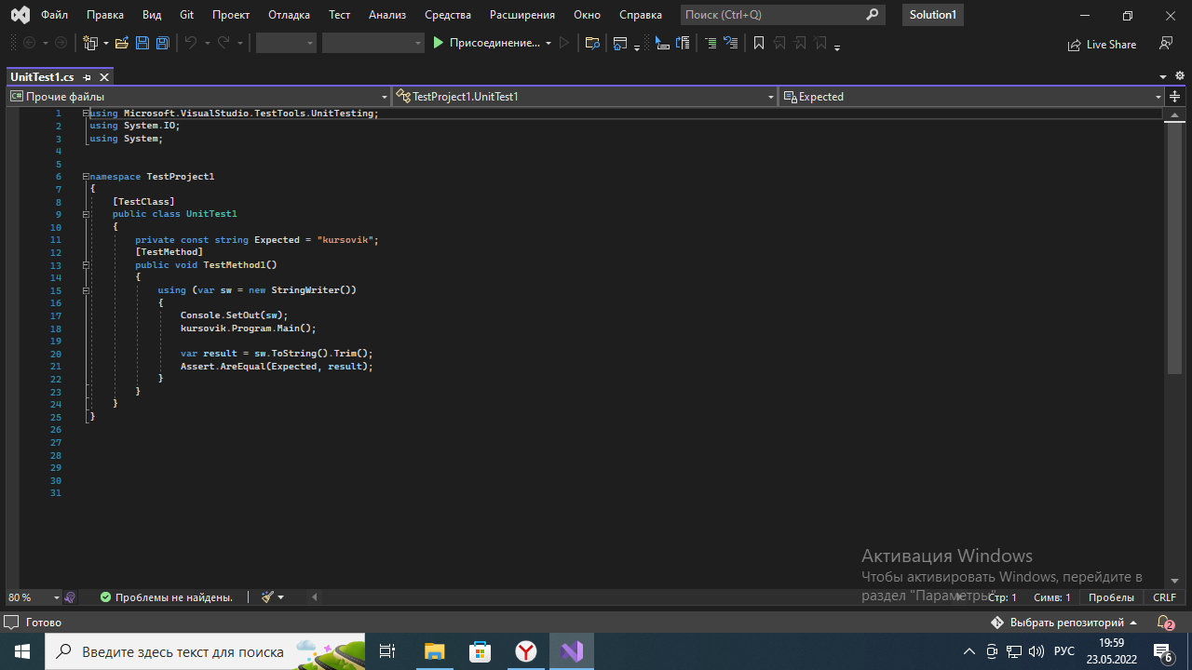

Рисунок 6. Юнит-тест